**dropdown.php**

<?php

include './Database/Controler.php';

//Year Dropdown

if(isset($_REQUEST["crs"]))

{

?>

<option value="">Select Year</option>

<?php

foreach($year_data as $y)

{

?>

<option value="<?php echo $y->year; ?>"><?php echo $y->year?></option>

<?php

}

}

//Division dropdown

if(isset($_REQUEST["year"]))

{

?>

<!<option value="">Select Division</option>

<?php

if($_SESSION["sess_crs"]==0)

{

if($_REQUEST["year"]=='First' || $_REQUEST["year"]=='Second' || $_REQUEST["year"]=='Third')

{

$arr=array("A","B","C");

}

else

{

$arr=array("A","B");

}

for($i=0;$i<count($arr);$i++)

{

?>

<option value="<?php echo $arr[$i] ;?>"><?php echo $arr[$i];?></option>

<?php

}

}

else

{

$arr=array("A","B","C");

for($i=0;$i<count($arr);$i++)

{

?>

<option value="<?php echo $arr[$i] ;?>"><?php echo $arr[$i];?></option>

<?php

}

}

}

//Hour dropdown

if(isset($_REQUEST["section"]))

{

?>

<option value="">Select Hour</option>

<?php

if($_SESSION["sess_crs"]==0)

{

$arr=array("1","2","3","4","5","6","7");

for($i=0;$i<count($arr);$i++)

{

?>

<option value="<?php echo $arr[$i] ;?>"><?php echo $arr[$i];?></option>

<?php

}

}

else

{

$arr=array("1","2","3","4","5","6","7");

for($i=0;$i<count($arr);$i++)

{

?>

<option value="<?php echo $arr[$i] ;?>"><?php echo $arr[$i];?></option>

<?php

}

}

}

//Subject dropdown

if(isset($_REQUEST["hour"]))

{

?>

<option value="">Select Subject</option>

<?php

foreach($sub_res as $c)

{

?>

<option value="<?php echo $c->usub_id;?>"><?php echo $c->sub_name; ?></option>

<?php

}

}

//subject faculty list

if(isset($_REQUEST["crs_fac"]))

{?>

<option value="">Select Faculty</option>

<?php

foreach($sub_fac as $sf)

{

?>

<option value="<?php echo $sf->ufac_id;?>"><?php echo $sf->fac_name;?></option>

<?php

}

}

?>

**Controler.php**

//Logout

if (isset($_REQUEST["logout"])) {

session_destroy();

header("location:index.php");

}

//Attendance Submit

if (isset($_REQUEST["att_submit"])) {

$total = $_SESSION["atotal"];

$date = $_SESSION["att"]["dt"];

$sub = $_SESSION["att"]["sub"];

$period = $_SESSION["att"]["period"];

$cl = array();

for ($i = 1; $i <= $total; $i++) {

$where = array(

"date" => $date,

"period" => $period,

"s_enrl" => $_REQUEST["r$i"]

);

$students_attendance = $md->sel_where($con, "attendance", $where);

if (isset($students_attendance)) {

$cl[$i] = $_REQUEST["r$i"];

$where = array(

"date" => $date,

"s_enrl" => $_REQUEST["r$i"],

"period" => $period

);

$data=array(

"present" => $_REQUEST["ch$cl[$i]"]

);

$table = "attendance";

$md->updt_at($con, $data, $table, $where);

}

header("location:at.php");

}

**Model.php:**

class model

{

function updt_at($con,$data,$table,$where)

{

$q="update $table set ";

foreach($data as $k=>$v)

{

$q.="$k='$v',";

}

$q=rtrim($q,",");

$q.=" where 1=1 ";

foreach($where as $m=>$n)

{

$q.=" and $m='$n'";

}

$con->query($q);

}

function sel1($con,$table,$colm,$where)

{

$q="select distinct $colm from $table where 1=1";

foreach($where as $k=>$v)

{

$q.=" and $k='$v'";

}

}

}

**footer.php**

<html>

<body>

<!-- JQUERY SCRIPTS -->

<script src="assets/js/jquery-1.10.2.js"></script>

<!-- BOOTSTRAP SCRIPTS -->

<script src="assets/js/bootstrap.min.js"></script>

<!-- METISMENU SCRIPTS -->

<script src="assets/js/jquery.metisMenu.js"></script>

<!-- CUSTOM SCRIPTS -->

<script>

$(document).ready(function() {

$('.trigger').click(function(){

var obj =$(this).parent().find('ul');

if(obj.hasClass("in")){

obj.removeClass('in');

}else{

obj.addClass("in");

}

});

});

</script>

</body>

</html>

**Teacher**

* **Attendance**

**at.php**

<?php

include './Database/Controler.php';

include 'role.php';

?>

<!--<script src="https://ajax.googleapis.com/ajax/libs/jquery/3.2.1/jquery.min.js"></script>-->

<script language="javascript" type="text/javascript">

function getYear(crs)

{

var crs=crs;

if(crs)

{

$.ajax({

type:"GET",

url:"dropdown.php",

data:"crs="+crs,

success:function(result)

{

$("#year").html(result);

}

});

}

}

function getSemester(yr)

{

var yr=yr;

if(yr)

{

$.ajax({

type: "GET",

url:"dropdown.php",

data:"yr="+yr,

success:function(result)

{

$("#semester").html(result);

}

});

$.ajax({

type: "GET",

url:"dropdown.php",

data:"year="+yr,

success:function(result)

{

$("#division").html(result);

}

});

}

}

function getHours(section)

{

var section=section;

$.ajax({

type: "GET",

url:"dropdown.php",

data:"section="+section,

success:function(result)

{

$("#hour").html(result);

}

});

}

function getSubject(hour)

{

var hour=hour;

if(hour)

{

$.ajax({

type: "GET",

url:"dropdown.php",

data:"hour="+hour,

success:function(result)

{

$("#subject").html(result);

}

});

}

$.ajax({

type: "GET",

url:"dropdown.php",

data:"section="+section,

success:function(result)

{

$("#hour").html(result);

}

});

}

function getFac(sub)

{

var sub=sub;

var cid=document.getElementById("c_id").value;

//var sem=document.getElementById("semester").value;

if(sub)

{

$.ajax({

type: "GET",

url:"dropdown.php",

data:"sub="+sub,

success:function(result)

{

$("#fac").val(result);

}

});

}

}

function checkhd(dt)

{

var atdt=dt;

$.ajax({

type: "GET",

url:"dropdown.php",

data:"atdt="+atdt,

success:function(result)

{

if(result!="")

alert(result);

}

});

}

</script>

<script language="javascript" src="./assets/js/validation.js"></script>

<script language="javascript">

function validate_form(f1)

{

if(isEmpty(f1.academic_yr.value,"Academicr year"))

{

alert(errMsg);

f1.academic_yr.focus();

return (false);

}

if(isEmpty(f1.c_id.value,"the Stream"))

{

alert(errMsg);

f1.c_id.focus();

return (false);

}

if(isEmpty(f1.subject.value,"the Subject"))

{

alert(errMsg);

f1.subject.focus();

return (false);

}

if(isEmpty(f1.dt.value,"the Date"))

{

alert(errMsg);

f1.dt.focus();

return (false);

}

if(isEmpty(f1.division.value,"the Division"))

{

alert(errMsg);

f1.division.focus();

return (false);

}

if(isEmpty(f1.hour.value,"the Hour"))

{

alert(errMsg);

f1.hour.focus();

return (false);

}

}

</script>

<h2>Attendance Details</h2>

</div>

</div>

<div class="row">

<div class="col-md-12">

<div class="panel panel-default">

<div class="panel-body">

<div class="table-responsive">

<form method="post" onSubmit="return validate_form(this)">

<table class="table table-striped table-bordered table-hover" id="dataTables-example">

<thead>

<td>

<b>Select Academic Year:<select class="form-control" id="academic_yr" name="a_yr" >

<?php

if (isset($a_y))

{

foreach ($a_y as $y)

{

?>

<option value="<?php echo $y->ac_year_id;?>"><?php echo $y->ac_year; ?></option>

<?php

}

}

?>

</select></b>

</td>

<td>

<b>Select Class:<select class="form-control" id="c_id" name="c_id" onChange="return getSemester(this.value)">

<option value="">Select Class</option>

<?php if(isset($crs)){$cnt=0;foreach($crs as $c){$cnt++; ?>

<option value="<?php echo $c->c_id; ?>"><?php echo $c->cname; ?></option>

<?php if($cnt=='2'){break;}}}?>

</select></b>

</td>

</tr>

<tr>

<td>

<div class="form-group">

<b>Select Section:

<select class="form-control" id="division" name="division" onChange="return getHours(this.value)">

<option value="">Select Section</option>

</select>

</div>

</td>

<td><div class="form-group">

<b>Select Hour:

<select class="form-control" id="hour" name="hour" onChange="return getSubject(this.value)">

<option value="">Select Section</option>

</select>

</div>

</td>

</tr>

<!-- <tr>

<td><b>Select Year :<select id="year" class="form-control" name="year" >

</select></b></td>

<td>

<b>Select Semester:<select class="form-control" id="semester" name="semester" onChange="return getSubject(this.value)">

</select></b>

</td>

</tr> -->

<tr>

<td><b>Select Subject :<select class="form-control" id="subject" name="subject" onchange="return getFac(this.value)">

</select></b></td>

<td><b>Faculty Name:<input type="text" name="fac" id="fac" class="form-control" disabled=""></b></td>

</tr>

<tr>

<td id="new_batch" colspan="2"></td>

</tr>

<tr>

<td><b>Select Date:<input class="form-control" type="Date" name="dt" id="dt" onchange="return checkhd(this.value)">

</b></td>

<!-- <td colspan="3">

<div class="form-group">

<b>Select Division:

<select class="form-control" id="division" name="division">

<option value="">Select Division</option>

</select>

</div>

</td> -->

</tr>

</thead>

<tr>

<td colspan="5"><center>

<button type="submit" id="act_submit" name="act_submit" value="submit" class="btn btn-primary"style="height: 100%; width: 30%;" >Submit</button>

</center></td>

</tr>

</table>

</form>

</div>

</div>

</div>

<!--End Advanced Tables -->

</div>

</div>

</div>

</div>

<?php

include 'footer.php';

?>

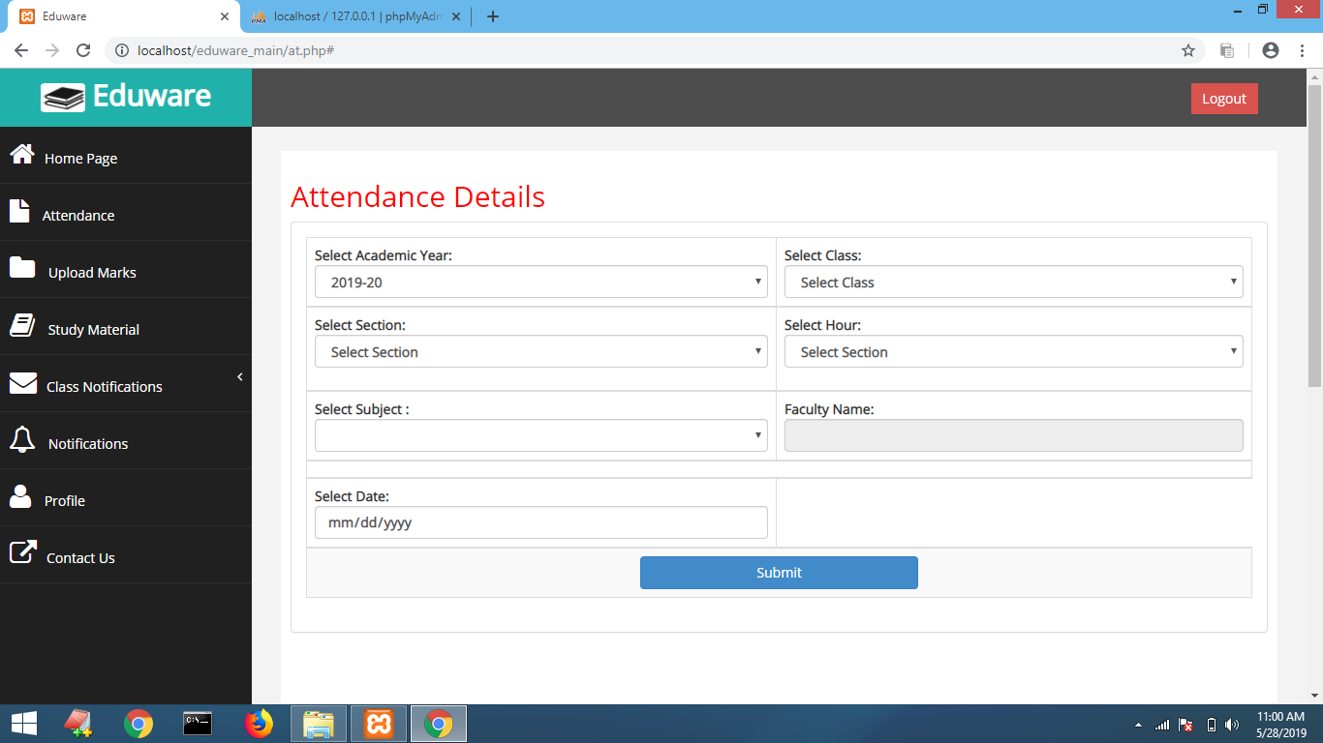

**act_attendance1.php**

<?php

include './Database/Controler.php';

include 'role.php';

?>

<script>

function like(rn)

{

var i=rn;

$.ajax({

type: "GET",

url:"at_clr.php",

data:"lid="+document.getElementById(i).style.color,

success:function(result)

{

if(document.getElementById(i).style.color=="green")

{

$("#").html(result);

$("#ch"+i).val(result);

var c="red";

document.getElementById(i).style.color=c;

}

else

{

$("#").html(result);

result='1';

$("#ch"+i).val(result);

var c="green";

document.getElementById(i).style.color=c;

}

}

});

}

</script>

<h2>Attendance Sheet</h2>

</div>

</div>

<!-- /. ROW -->

<div class="row">

<div class="col-md-12">

<div class="panel panel-default">

<br>

&emsp;<b>Faculty Name:</b> <?php echo $_SESSION["my_fac"]; ?>

&emsp;&emsp;&emsp;<b> Subject:</b>

<?php

foreach($_SESSION["sn"] as $sn)

{

echo $sn->sub_name;

}

?>

&emsp;&emsp;&emsp; <b> Date:</b><?php echo $_SESSION["att"]["dt"]; ?>

&emsp;&emsp;&emsp; <b> Division:</b><?php echo $_SESSION["att"]["div"]; ?>

<br>

<?php

if($_SESSION["q1"])

{ //echo "<pre>";

//print_r($_SESSION["q1"]);exit;

?>

<div style="float:right;">

<form method="post">

<button type="submit" id="all_pr" name="all_pr" class="btn btn-success">All Present</button>

<button type="submit" id="all_ab" name="all_ab" class="btn btn-danger">All Absent</button>&emsp;

</form>

</div><br><br>

<!-- Advanced Tables -->

<center>

<form method="post" role="form" enctype="multipart/form-data">

<?php

$_SESSION["atotal"]=sizeof($_SESSION["q1"]);

$cnt=0;

foreach ($_SESSION["q1"] as $k => $v)

{

$cnt++;

?>

<a href="#">

<i class="fa fa-user fa-2x" id="<?php echo $v->s_enrl;?>" name="<?php echo $v->s_enrl;?>"

<?php

if(isset($_REQUEST["all_pr"]))

{

echo 'style="color:green;"';

}

elseif(isset($_REQUEST["all_ab"]))

{

echo 'style="color:red;"';

}

else

{

echo 'style="color:green;"';

}

?>

onClick="return like(<?php echo $v->s_enrl;?>);">

<?php echo "<br><h6>".$v->s_rn."</h6>"; ?>

</i>

</a>

<input type="hidden" value="<?php echo $v->s_enrl; ?>" id="<?php echo "r".$cnt; ?>" name="<?php echo "r".$cnt; ?>">

<input type="hidden" name="<?php echo "ch".$v->s_enrl; ?>" id="<?php echo "ch".$v->s_enrl; ?>"

<?php

if(isset($_REQUEST["all_pr"]))

{

echo 'value="1"';

}

elseif(isset($_REQUEST["all_ab"]))

{

echo 'value="0"';

}

else

{

echo 'value="1"';

}

?>

>

&emsp;

<?php

}

?>

<center><br>

<button type="submit" id="att_submit" name="att_submit" value="submit" class="btn btn-primary"style="height: 100%; width: 30%;">Submit</button>

</center> <br>

</form>

<?php

}

else

{

echo "<br><center><b><h3>No Student Available...<br>Please Add students First...</h3></b></center><br>";

echo "<a href='bulk_stu_det.php'><center><b>Add Multiple Stuudent From here</b></center></a><br>";

}

?>

</center>

</div>

</div>

</div>

<!-- end Context Classes -->

</div>

</div>

<!-- /. ROW -->

</div>

</div>

<!-- /. PAGE INNER -->

</div>

<!-- /. PAGE WRAPPER -->

<!-- /. WRAPPER -->

<!-- SCRIPTS -AT THE BOTOM TO REDUCE THE LOAD TIME-->

<?php

include 'footer.php';

?>

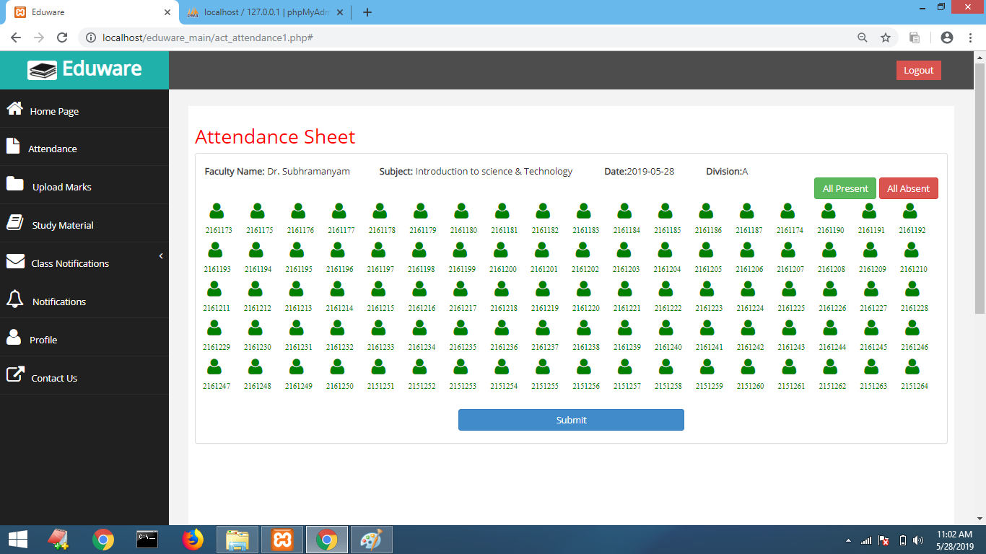

**at_clr.php**

<?php

include './Database/Controler.php';

if(isset($_REQUEST['lid'])=="green")

{

echo '0';

}

else

{

echo '1';

}

?>

* **Study Material (uploading)**

**Sm_upload.php**

<?php

include 'header_fac.php';

include './Database/Controler.php';

include 'filesLogic.php';?>

<form style= "width: 30%;margin: 100px auto;padding: 30px;border: 1px solid #555;"action="sm_upload.php" method="post" enctype="multipart/form-data" >

<h3 style="color:orangered">Upload File</h3>

<input type="file" name="myfile"> <br>

<button style=type="submit" name="save"class="btn btn-primary">Upload</button>

</form>

<?php

include_once 'footer.php';

?>

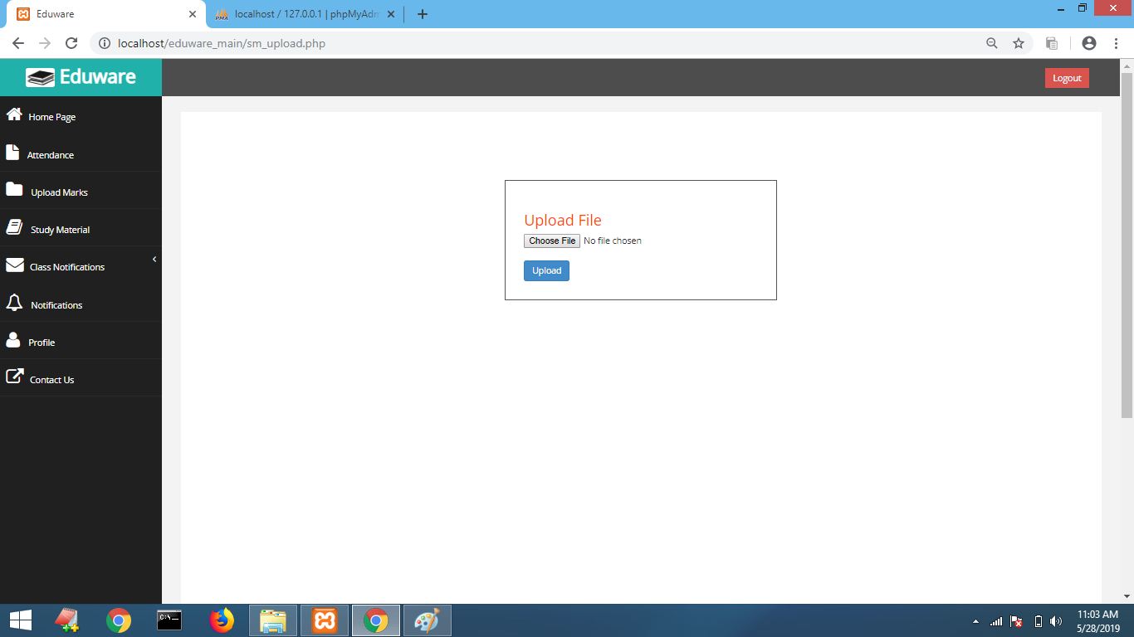

**filesLogic.php**

<?php

// connect to the database

$conn = mysqli_connect('localhost', 'root', '', 'sams');

$sql = "SELECT * FROM files";

$result = mysqli_query($conn, $sql);

$files = mysqli_fetch_all($result, MYSQLI_ASSOC);

// Uploads files

if (isset($_POST['save'])) { // if save button on the form is clicked

// name of the uploaded file

$filename = $_FILES['myfile']['name'];

// destination of the file on the server

$destination = 'uploads/' . $filename;

// get the file extension

$extension = pathinfo($filename, PATHINFO_EXTENSION);

// the physical file on a temporary uploads directory on the server

$file = $_FILES['myfile']['tmp_name'];

$size = $_FILES['myfile']['size'];

if (!in_array($extension, [ 'pdf', 'docx'])) {

echo "You file extension must be .pdf or .docx";

} elseif ($_FILES['myfile']['size'] > 1000000) { // file shouldn't be larger than 1Megabyte

echo "File too large!";

} else {

// move the uploaded (temporary) file to the specified destination

if (move_uploaded_file($file, $destination)) {

$sql = "INSERT INTO files (name, size, downloads) VALUES ('$filename', $size, 0)";

if (mysqli_query($conn, $sql)) {

echo "File uploaded successfully";

}

} else {

echo "Failed to upload file.";

}

}

}

// Downloads files

if (isset($_GET['file_id'])) {

$id = $_GET['file_id'];

// fetch file to download from database

$sql = "SELECT * FROM files WHERE id=$id";

$result = mysqli_query($conn, $sql);

$file = mysqli_fetch_assoc($result);

$filepath = 'uploads/' . $file['name'];

if (file_exists($filepath)) {

header('Content-Description: File Transfer');

header('Content-Type: application/octet-stream');

header('Content-Disposition: attachment; filename=' . basename($filepath));

header('Expires: 0');

header('Cache-Control: must-revalidate');

header('Pragma: public');

header('Content-Length: ' . filesize('uploads/' . $file['name']));

readfile('uploads/' . $file['name']);

// Now update downloads count

$newCount = $file['downloads'] + 1;

$updateQuery = "UPDATE files SET downloads=$newCount WHERE id=$id";

mysqli_query($conn, $updateQuery);

exit;

}

}

* **Profile**

**fac_profile.php**

<?php

include './Database/Controler.php';

include 'role.php';

?>

<h2>Profile</h2>

<?php

if( ! $_SESSION)

{

session_start();

}

?>

<div class="row">

<div class="col-md-12">

<div class="panel panel-default">

<div class="panel-body" style="background-color: #F8F8F8;">

<div class="table-responsive">

<table class="table table-striped table-bordered table-hover" id="dataTables-example">

<?php

$where= array(

"ufac_id"=>$_SESSION['ufac_id']

);

$image=$md->sel1($con,"faculty","fac_gen",$where);

if(strcasecmp($image[0]->fac_gen,"male")==0)

{

?>

<center><br><img src="img/m.jpg" height="10%" width="20%" style="border-radius:50%;"></center><br>

<?php }else { ?>

<center><br><img src="img/f.jpg" height="10%" width="20%" style="border-radius:50%;"></center><br>

<?php } ?>

<?php

$mysqli = new mysqli("localhost", "root", "","sams");

$query = "SELECT ufac_id,fac_name,email,contact FROM faculty WHERE ufac_id='".$_SESSION["ufac_id"]."'";

// var_dump($query);

/*$query="SELECT * FROM student WHERE s_rn='2161173'";*/

if($result = $mysqli->query($query))

{

while($row = $result->fetch_assoc())

{?>

<b><h3><center><?php echo "<b>Faculty Name:</b> ". $row['fac_name']; ?></center></h3></b>

<h4><center> <?php echo "<b>Faculty Id:</b> ".$row['ufac_id']; ?></center>

<h4><center> <?php echo "<b>Email:</b> ".$row['email']; ?></center>

<h4><center> <?php echo "<b>Contact:</b> ".$row['contact']; ?></center>

<?php

}

$result->free();

}

?>

</table>

<?php

include 'footer.php';

?>

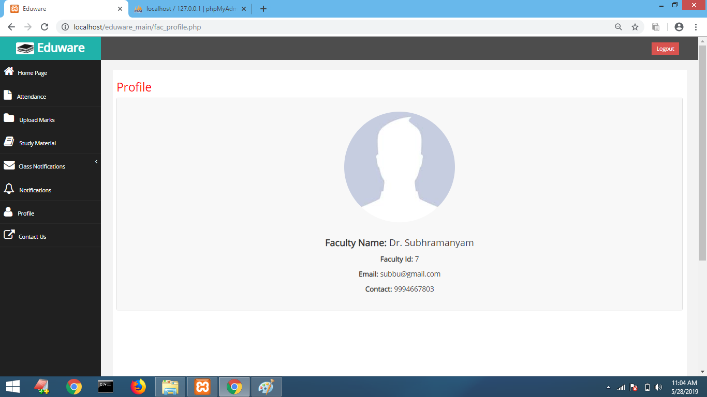

**Student**

* **Download Study Material**

**Downloads.php**

<?php

include 'filesLogic.php';

include './Database/Controler.php';

?>

<!DOCTYPE html>

<html>

<head>

<meta charset="utf-8" />

<!--<link rel="stylesheet" href="style.css">-->

<title>Download files</title>

</head>

<body>

<table class="table table-striped table-bordered table-hover" id="dataTables-example">

<thead style="color:white;background:#202020;">

<th align="center" width="6%">ID</th>

<th align="center" width="20%">Filename</th>

<th align="center" width="10%">size </th>

<th align="center" width="10%">Downloads</th>

<th align="center" width="10%">Action</th>

</thead>

<tbody>

<?php $cnt=1; foreach ($files as $file): ?>

<tr>

<td><?php echo $cnt++; ?></td>

<td><?php echo $file['name']; ?></td>

<td><?php echo floor($file['size'] / 1000) . ' KB'; ?></td>

<td><?php echo $file['downloads']; ?></td>

<td><a href="downloads.php?file_id=<?php echo $file['id'] ?>">Download</a></td>

</tr>

<?php endforeach;?>

</tbody>

</table>

</body>

</html>

<?php

include 'footer.php';

?>

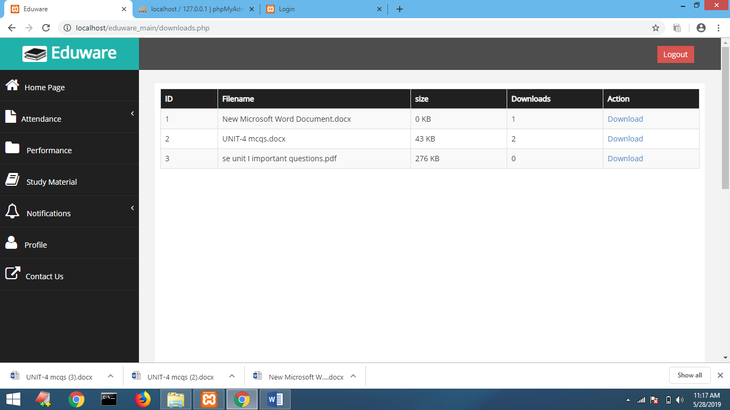

* **Profile**

**student_profile.php**

<?php

include './Database/Controler.php';

include 'role.php';

//include './Database/Model.php';

?>

<h2>Profile</h2>

<?php

if( ! $_SESSION)

{

session_start();

}

?>

<div class="row">

<div class="col-md-12">

<div class="panel panel-default">

<div class="panel-body" style="background-color: #F8F8F8;">

<div class="table-responsive">

<table class="table table-striped table-bordered table-hover" id="dataTables-example">

<?php

$where= array(

"s_rn"=>$_SESSION['s_rn']

);

$image=$md->sel1($con,"student","s_gen",$where);

if(strcasecmp($image[0]->s_gen,"male")==0)

{

?>

<center><br><img src="img/m.jpg" height="10%" width="20%" style="border-radius:50%;"></center><br>

<?php }else { ?>

<center><br><img src="img/f.jpg" height="10%" width="20%" style="border-radius:50%;"></center><br>

<?php } ?>

<?php

$mysqli = new mysqli("localhost", "root", "","sams");

$query = "SELECT * FROM student WHERE s_rn='".$_SESSION['s_rn']."'";

// var_dump($query);

/*$query="SELECT * FROM student WHERE s_rn='2161173'";*/

if($result = $mysqli->query($query))

{

while($row = $result->fetch_assoc())

{?>

<b><h3><center><?php echo "<b>First name:</b> ". $row['fnm']; ?></center></h3></b>

<h4><center> <?php echo "<b>Student Id:</b> ".$row['s_rn']; ?></center>

<h4><center> <?php echo "<b>Gender:</b> ".$row['s_gen']; ?></center>

<h4><center> <?php echo "<b>Contact:</b> ".$row['contact']; ?></center>

<?php

}

$result->free();

}

?>

</table>

<?php

include 'footer.php';

?>

